**Human Computer Interaction**

**Final Project**

**Med-Ex**

For a convenient medical experience!

**Report**

**By**

**Shruti Puranik**

**spuranik@hawk.iit.edu**

**Introduction to the Product**

MED-EX is a convenient medical expense tracker, that allows any user to enter total medical expenses occurred which include procedural costs, insurance coverage costs, deductibles paid, amount paid by self and most importantly verifies the balance to be paid by the user.

**Goals to be accomplished by the Team**

* Buy Medical Insurance
* Book Doctors Appointment
* Track Medical Expenses

**APPLICATION FLOW DIAGRAM**

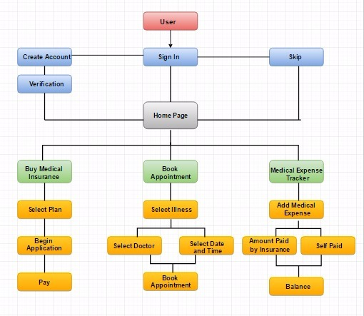

**GOAL - BUY INSURANCE**

**Introduction**

eHealth (also written e-health) is a relatively recent term for healthcare practice supported by electronic processes and communication, dating back to at least 1999. This web portal Delivers an ecommerce experience for consumers to compare, buy, and use the health insurance products, tools, and information that protect their well-being for life.

**CONTEXTUAL ENQUIRY ON EXISTING WEB PORTAL TO COMPARE AND BUY HEALTH INSURANCE**

**Task -** Buy medical insurance online.

Platform - Web browser (Chrome)

**USER 1** - Industry professional - Age 38

The user is a trained health care professional and has prior experience in buying medical insurance online earlier for herself and has also helped his friends in the same task. This user has also many health-related applications.

**STEPS:**

1. Open’s ehealth insurance web site (www.ehealthinsurance.com) and enters her login credentials as she has a profile created earlier.

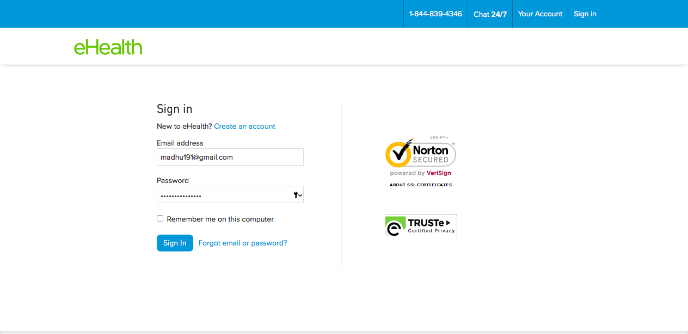

2. She clicks the “more” option on the screen and selects health insurance option.

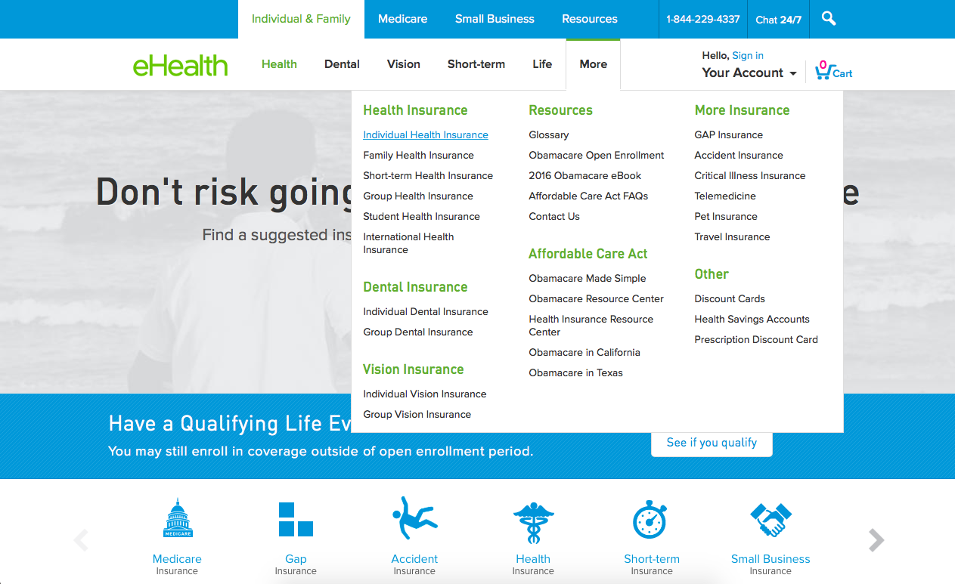

3. She clicks “Individual health insurance option”.

4. The user now sees a kind of application where she needs to fill out personal details like gender, date of birth and income. The user also is asked to enter Zip code.

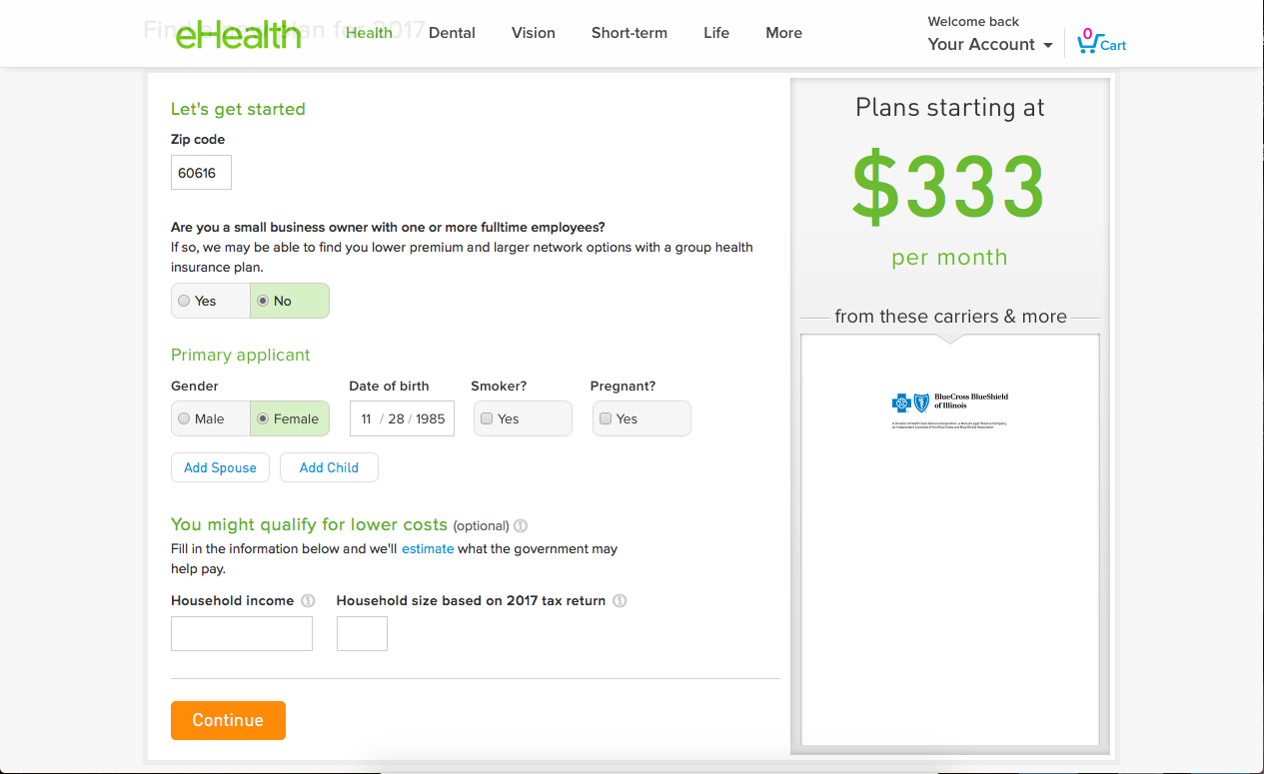

5. After the user clicks continue, she is provided with a list of insurance plans’ from different providers.

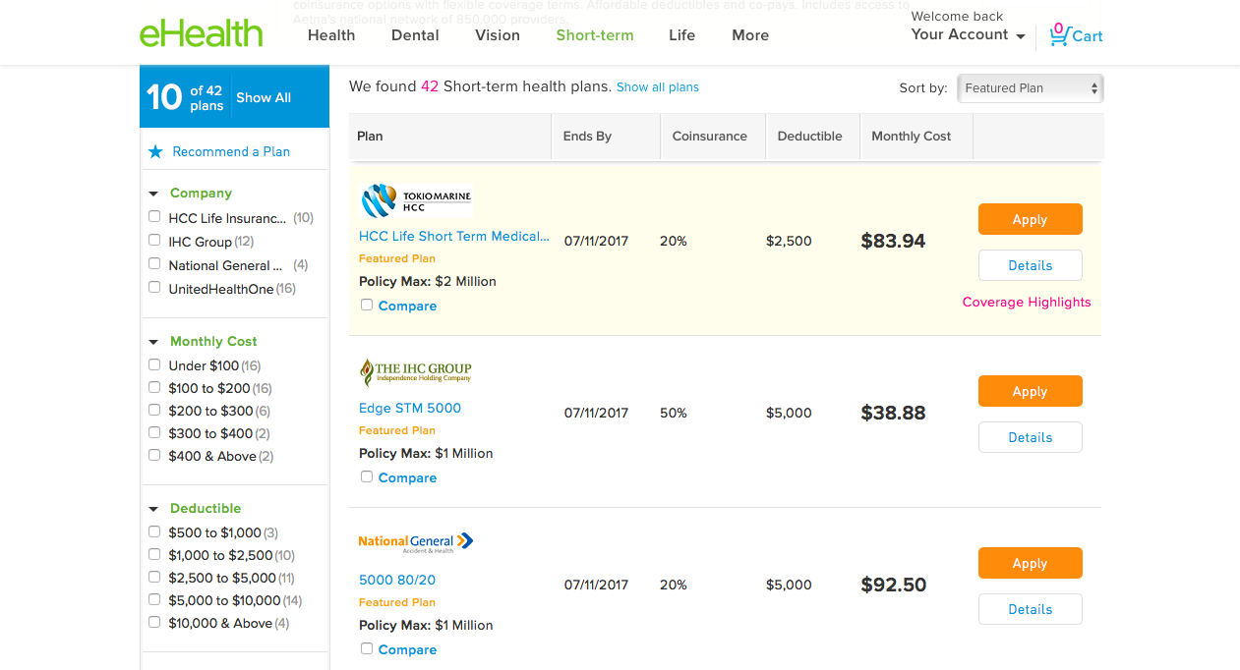

6. The user had a policy prior to this with United Health One and hence was looking for this option in particular. She clicked the filter option on the left of the screen and Selected Unitedhealth option.

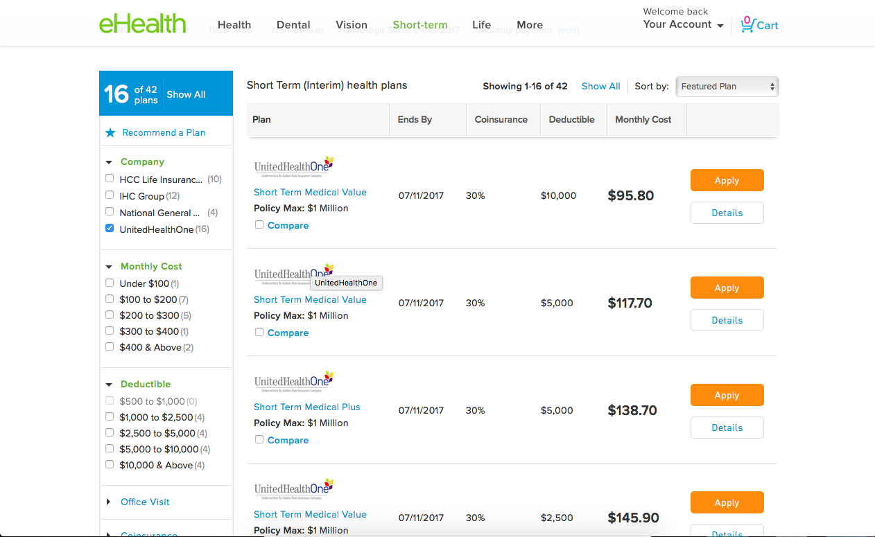

7. She checks the details of a couple of insurances before selecting the one with better coverage for her needs.

8. She confirms the selected plan by clicking “apply” and the insurance plan is added to the cart.

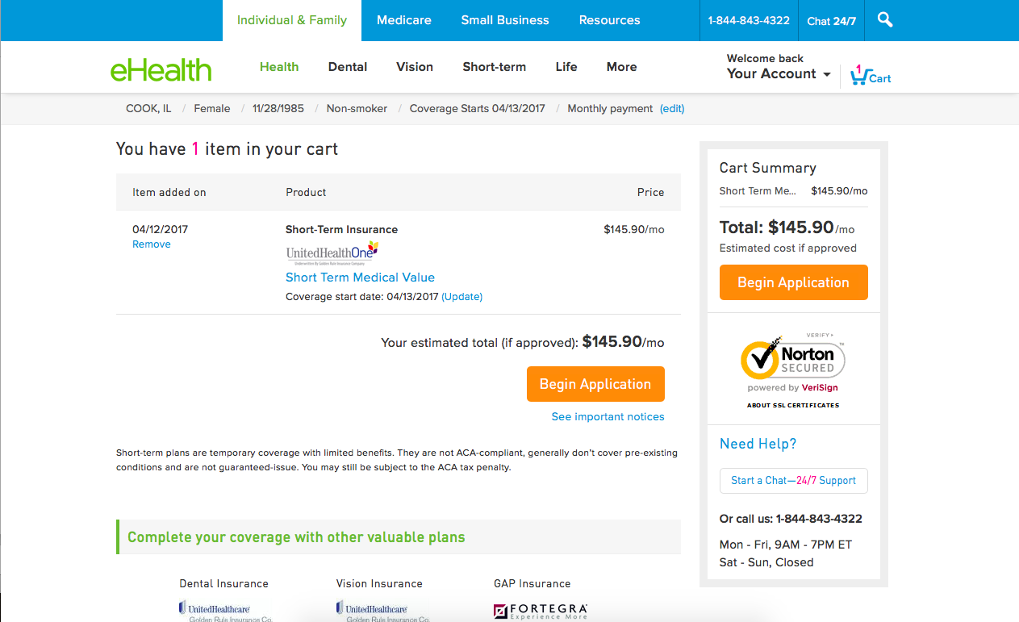

9. She clicks on “Begin Application” where she fills out her personal credentials and clicks “Continue”

10. The user is again asked to fill in her address details followed by eligibility questions.

11. The user then proceeds to the payment section where she selects the credit card option and clicks “Continue”

12. The user gets a payment confirmation and the insurance policy with the details are mailed to her personal mail id.

**USER 1 EXPERIENCE -**

The entire experience was smooth and the details provided for the policies were clear. The website was user friendly.

**User 2** - Graduate Student - Age 26

The user is currently a graduate student. She had insurance that was bought by her parents and is looking to buy new insurance for herself and is unfamiliar with the possible options. She has been advised to view the policies available online but has not yet explored the same.

**STEPS:**

1. She searches her options of insurance providers in USA on google.

2. The user scrolls through the results and finds a varied list which has names of insurance providers, benefits and news.

3. She decides to go with eHealth insurance website because it is the first relevant search result which includes insurance providers, compares policies and the premium information.

4. She enters the web site but is not sure where to click to buy or get insurance policy details. She explores the web page and after trial and error and finally clicks health option.

5. The user now sees a kind of application where she needs to fill out personal details like gender, date of birth and income. The user also is asked to enter Zip code.

6. Since the user is a first time applicant, she is asked to register and complete her profile and then is shown an array of insurance policies.

7. She checks the details of a couple of insurances before selecting the one with better coverage for her needs.

8. She confirms the selected plan by clicking “apply” and the insurance plan is added to the cart.

9. She clicks on “Begin Application” where she fills out her personal credentials and clicks “Continue”

10. The user is again asked to fill in her address details followed by eligibility questions. The user was confused in this step as the address details asked were redundant.

11. The user then proceeds to the payment section where she selects the credit card option and clicks “Continue”

12. The user gets a payment confirmation and the insurance policy with the details are mailed to her personal mail id.

**USER 2 EXPERIENCE -**

Being a first time user, the experience was not really very smooth. Firstly, the user did not know clearly where to click/check for insurance plans as there were no clear labels. The user strongly felt that there was redundant information being asked to fill out thereby making the process a little tedious.

**HEURISTIC EVALUATION ON THE EXISTING WEBSITE**

**TASK - Buy Medical Insurance**

**Platform - Web Site**

1**. Visibility of system status**: The website clearly lets the user know that it is a platform to buy medical insurance but the downside is that the user does not know where to start to view the plans initially. There is no clear label for a tab which tells the user to click to view insurance plans.

**2. Match between system and the real world** : The words used were not very specific to buy or view insurance plans like “ Buy or compare “, instead there were labels like “Dental”, “Vision”, “Short Term” which were quite confusing.



**3. User control and freedom**: Not very easy to go Back to the previous step unless we use the website back link.

**4. Consistency and Standards:** The labels were confusing as the user could not understand if they mean the same thing. For example, the label “Dental” was ambiguous to the user as they did not know if this was specific to Dental Insurance only and another Label called “Vision” was misleading too as the user did not understand if it was the organizations vision or eye insurance.

**5. Error prevention** : There was proper error checking in place and if the user made any mistake in filling out any details there were understandable error messages.

**6. Recognition rather than re-call** : Navigation through the pages is tedious due to several options available and recollecting every time is not easy for the user.

**7. Flexibility and efficiency of use** : There were many details which were required to fill even to view the insurance plans. Options related to insurance policies using many technical jargons are displayed and thus confusing the users especially the first timers. The content for many options was very verbose and thus difficult to read.

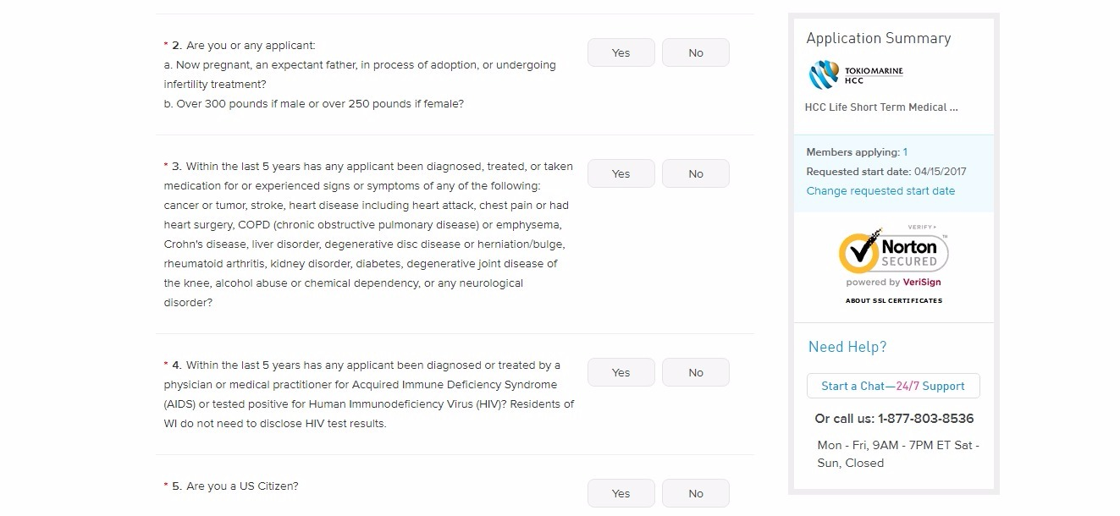

**8. Aesthetic and minimalist design** : The webpage design was good overall. The text and the images were displayed with a proper balance. The color usage was also minimal with only blue and white. The text was in black and some important information was colored in green for example the price of the insurance policy.

**9. Help Users recognize, diagnose and recover from errors** : The website gives proper indication of the problem and gives a constructive solution to retrieve back.

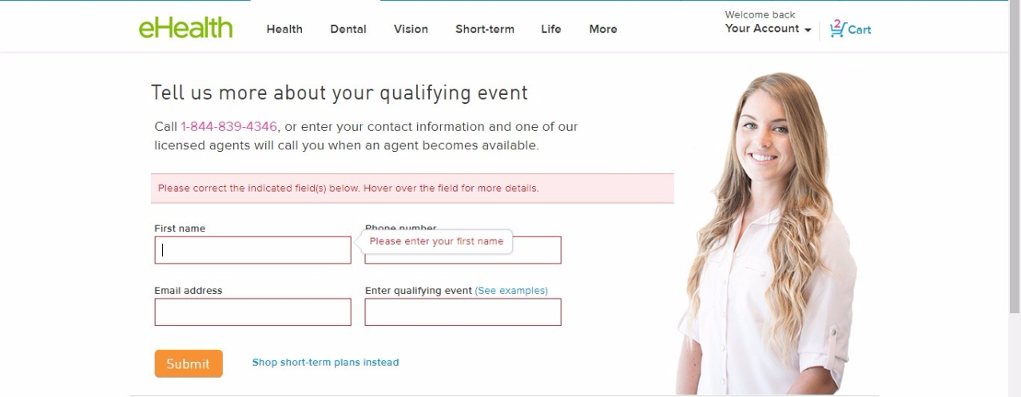

**10. Help and Documentation** : There is no help option to support the user through his navigation on the web site. There are no FAQ’s which could help the user with some common questions. There is no proper help provided in case the user does not know what to answer for a particular question.

**Flow Diagram Goal 1 Buy Medical Insurance**

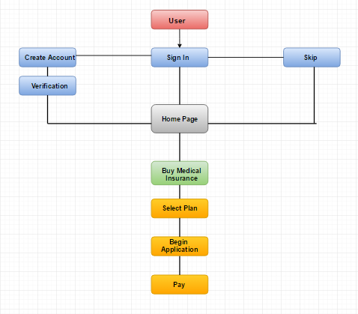

**Paper Prototyping for Med-Ex**

Login/Signup

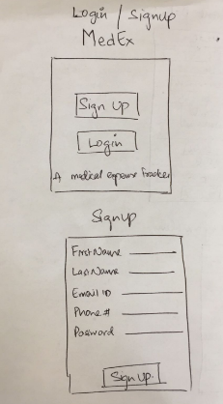

Menu Page

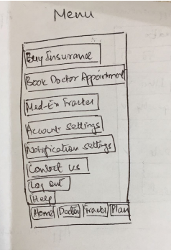

Goal 1: Buy Insurance plan

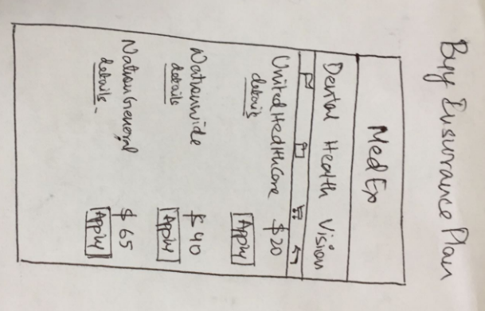

Insurance Details

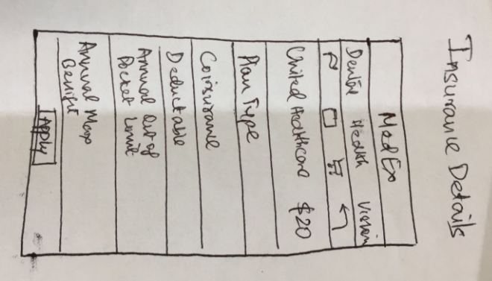

**Low Fidelity Prototype Goal-1 Buy Medical Insurance Iteration 1**

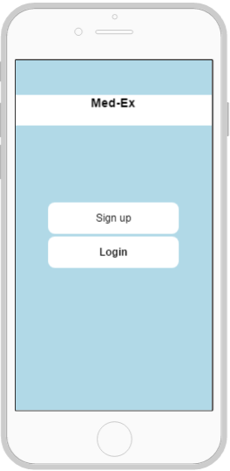 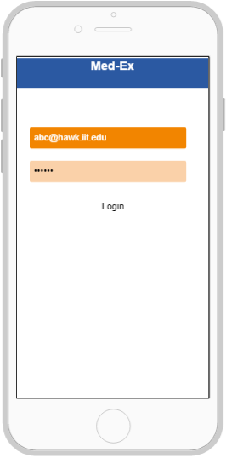

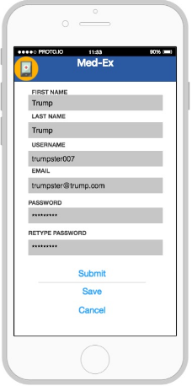 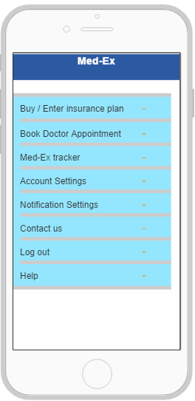

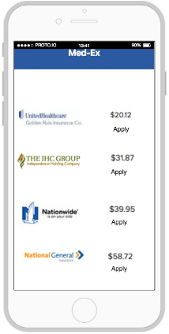 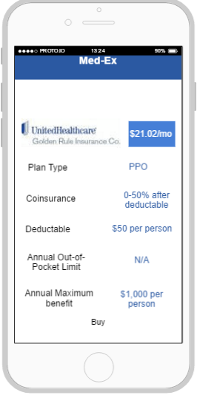

**HEURISTIC EVALUATION ON LOW FIDELITY DIAGRAM**

**1. Visibility of system status**: The website clearly lets the user know that it is a platform to buy medical insurance. The labels used are clearly understandable.

**2. Match between system and the real world :** The words used were very specific to buy or view insurance plans like “ Buy“ and ”Apply”, But the buttons used were more like a text.

**3. User control and freedom**: Not very easy to go Back to the previous step.

**4. Consistency and Standards :** The labels were clear as the user could understand if they mean the same thing. For example, the label “buy” to buy the insurance.

**5. Error prevention** : There was no proper error checking in place and if the user made any mistake in filling out any details there were no error messages.

**6. Recognition rather than re-call:** Navigation through the pages is tedious due to no proper back button. There were no proper images to represent the actions performed.

**7. Flexibility and efficiency of use:** Not very easy to go back to the previous step making the application less flexible, but the application was efficient in terms of performing the task.

**8. Aesthetic and minimalist design**: The webpage design was not great. There were no proper images displayed in the menu page. The color usage was also minimal. The buttons used were more like a text.

**9. Help Users recognize, diagnose and recover from errors:** The design was clear and chances of error are minimal.

**10. Help and Documentation**: There is a help option in the menu page to support the user through his navigation on the web site. There are no FAQ’s which could help the user with some common questions. There is no proper help provided in case the user does not know what to answer for a particular question.

**Low Fidelity Prototype Goal-1 Buy Medical Insurance Iteration 2**

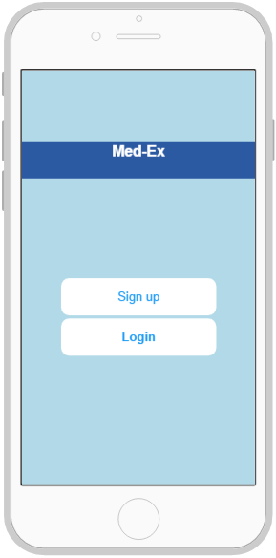 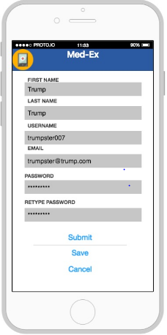

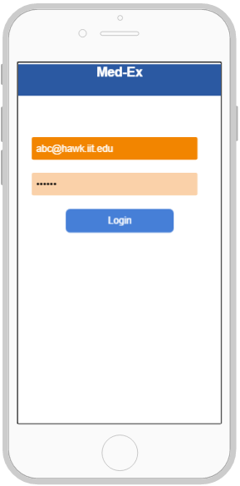 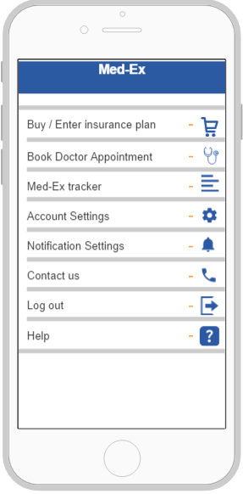

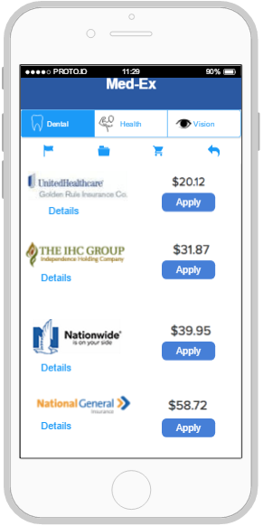 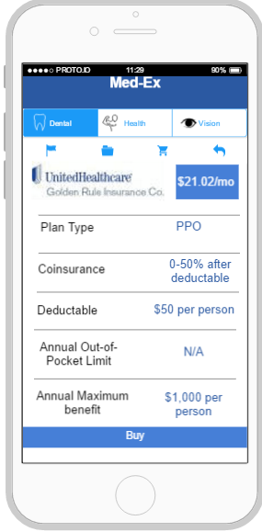 n 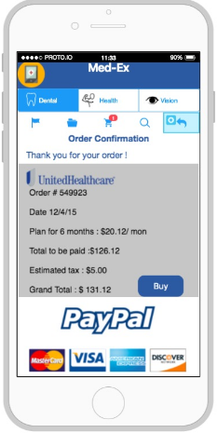 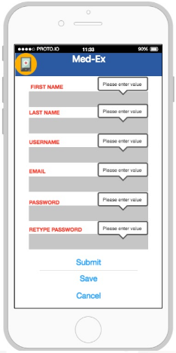

**HEURISTIC EVALUATION ON LOW FIDELITY DIAGRAM**

1. Visibility of system status: The website clearly lets the user know that it is a platform to buy medical insurance. The labels used are clearly understandable.

2. Match between system and the real world : The words used were very specific to buy or view insurance plans like “ Buy“ and ”Apply”.

3. User control and freedom: Easy to log out and go back to previous step . User can traverse back easily and could see the item added in the cart.

4. Consistency and Standards: The labels were clear as the user could understand if they mean the same thing. For example, the label “buy” to buy the insurance, “details” to view the insurance details.

5. Error prevention: There was proper error checking in place and if the user made any mistake in filling out any details there were understandable error messages.

6. Recognition rather than re-call: Navigation through the pages is easy due to back button. There were proper images to represent the actions performed.

7. Flexibility and efficiency of use: User could navigate through the pages easily; User could compare the insurance plans and could get the details of insurance hence making the application flexible and efficient.

8. Aesthetic and minimalist design: The webpage design was good overall. The text and the images were displayed with a proper balance. The color usage was also minimal with only blue and white. The text was in black and some important error information was colored in red for example the signup page when user tries to click submit button without entering any details.

9. Help Users recognize, diagnose and recover from errors: The design was clear and chances of error are minimal.

10. Help and Documentation: There is a help option in the menu page to support the user through his navigation on the web site.

**Contextual enquiry for Final Prototype**

**User 1:** Student at IIT, age- 23, User has used multiple mobile applications for expense tracking, however has not used any specific for medical expense tracking. The user has little or no experience with buying an insurance plans. Has been using the one provided by the university.

**Steps:**

1. The user being a first time user of the application clicks on Sign Up.

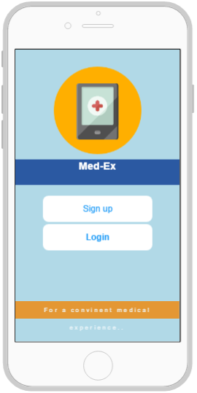

1. She is asked to fill in details like her name, email id and password. She clicks submit and completes the registration process.

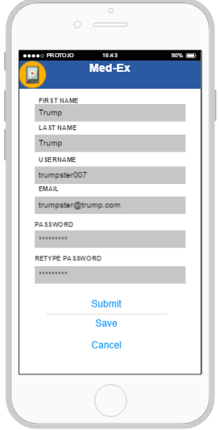

1. The user next is directed to the login screen and enters her username and password and logs in.
2. The user currently is looking for a doctor appointment hence form the menu on the screen she clicks the respective button”Book doctor appointment”.
3. The user is directed to the next screen where she is asked to select details from drop down such as “select type of illness”,”doctor's speciality” and “time and date”.
4. She clicks proceed and is directed to a page which displays the details of the doctor such as Doctors name, speciality and the address.
5. The user clicks on the Book appointment button and finalizes the particular doctor.
6. The user next navigates to the menu screen and clicks on Buy Insurance button.

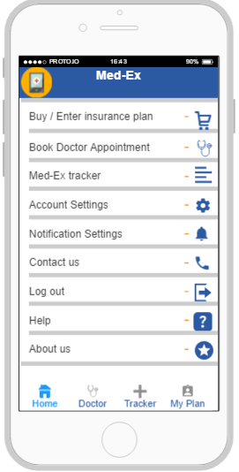

1. The user sees a list of insurance plans and decides on United Healthcare plan because her criteria is lowest premium. She clicks on Apply button.

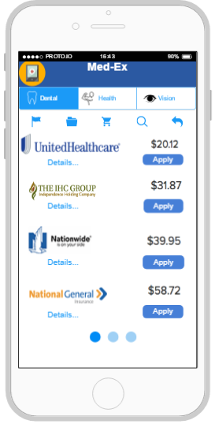

1. The user can now see the details of the insurance plan, she likes the information displayed on the screen and clicks on Buy button.

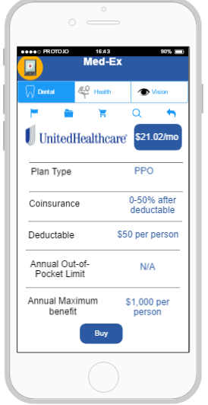

1. The user now sees order submission details and is given options from various credit cards to pay for the plan. She clicks Buy to finish the purchase.

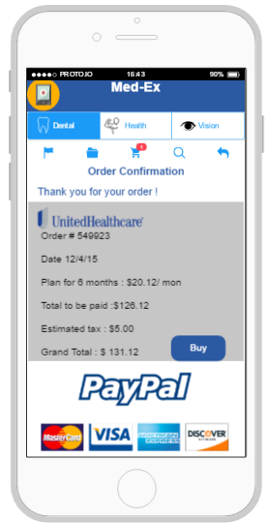

1. After visiting her doctor, she again logs in to the medex application and clicks on “Expense tracker option” on the menu screen.
2. The user gets a screen displaying details which have to be populated such as “ hospital name”, “medical procedural cost”, “insurance coverage” etc… She notices a “++ symbol on the top corner and clicks the same to add the current expense to the tracker.
3. The user is directed to a screen which shows her the expense details and the final amount she owes after all the deductions. The user is relieved that she does not have to do all the calculations.
4. The user logs out of the application.

**Heuristic Evaluation for Final Prototype**

**1. Visibility of system status:** The application has a smooth transition from one page to another. Each page has clear labels showing the app’s current status that helps the user understand the the app well and is convenient.

**2. Match between system and the real world:** The app uses icons that relate to the function specified, for instance buy insurance option lists the different plans available to choose from and after you buy it also provides with the order confirmation. The shopping cart icon also is a real world description of a purchase made.

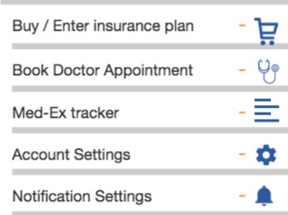

**3. User control and freedom**: User can navigate between the options to the home page with ease. At any given point the user has the freedom to choose from the tab bar to navigate directly to the tracker or the book doctor appointment option.

**4. Consistency and Standards**: The labels were real-time and consistent throughout the app, sizing of the images and fonts used, were also well defined. Standard basic colors such as white, blue, orange, grey and black are used.

**5. Error prevention**: There was proper error checking in place and if the user made any mistake in filling out any details there were understandable error messages with preventive action measures.

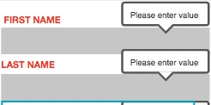

**6. Recognition rather than re-call:** Payment options are clearly listed for the user to identify the different payment methods. The words used to describe are simple and straightforward. For instance the option to purchase an insurance plan use the word “Buy” - which is a clear representation of the action to be performed.

**7. Flexibility and efficiency of use**: The application is designed in way to have easy access to the primary functions of the app on every page as the tab bar, giving the user flexibility and is efficient by saving time of the user.

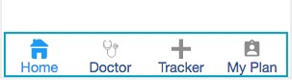

**8. Aesthetic and minimalist design**: The application design was good overall. Easily relatable symbols are used through the app for instance dental insurance plans are represented by a tooth symbol, find a doctor is represented by a stethoscope symbol. Minimal colors and options provided throughout the application.

**9. Help Users recognize, diagnose and recover from errors:** The design is simplistic and errors are shown in bold and red which indicates an incorrect input from the user. The error message that pops up also indicates the corrective action to prevent the error.

**10. Help and Documentation:** There is a help option in the home page to support the user while trying to use any of the functions on the app. Each of these options have details of either stepwise tutorials, or knowledge base articles that can be referred to.

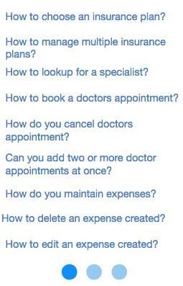

**GOAL - BOOK DOCTORS APPOINMENT**

**Introduction**

Zocdoc is an [online](https://en.wikipedia.org/wiki/Software_as_a_service) [medical care](https://en.wikipedia.org/wiki/Medical_care) [scheduling service](https://en.wikipedia.org/wiki/Calendaring_software), providing [free of charge](https://en.wikipedia.org/wiki/Freeware) medical care search facility for end users by integrating information about medical practices and doctors' individual schedules in a central location.

**CONTEXTUAL ENQUIRY ON EXISTING WEB PORTAL TO COMPARE AND BOOK DOCTORS APPOINTMENT**

**Task -** Book Doctors Appointment online.

Platform - Web browser (Chrome)

**USER 1** - Graduate student - Age 28

The user is a graduate student and is proficient in using internet for various services including buying medicines and availing other health related services.

**STEPS -**

1. The user searches for a particular website on Google. ( www.zopdoc.com)

2. The user enters the Zip code and clicks the search option.

3. The user is prompted with a popup to enter the existing insurance plan which is optional.

4. The user then selects the type of Illness from the Illness drop down.

5. The user selects the doctor based on the rating given and selects the particular date and time for the appointment.

6. The user is prompted for a confirmation dialog box to book an appointment and then clicks “Book appointment”.

7. The user is asked to enter their login credentials.

8. The user is prompted to select the insurance plans they are enrolled on and the user selects her appropriate plan form the list of dropdown.

9. The user clicks continue to proceed with the appointment.

10. The user is asked to enter her phone number for further verification.

11. The user can see her appointment confirmation on the screen.

**USER 1 - EXPERIENCE**

The overall experience was good but there was not much information available to the user about the doctors profile. The user felt that the website was easy to use with minimum steps but could be better by adding few other functionalities.

**USER 2 -** Student at IIT, age -22. The user is an international student and has not yet visited any doctor or a hospital. He is not familiar with the process of booking an appointment for any given sickness. User has good experience with using mobile applications.

**STEPS** -

1. The user searches for a applications to book doctor’s appointment on Google.

2. The user selects the first available result .([www.zocdoc](http://www.zocdoc).com)

3. The user enters the Zip code and clicks the search option.

4. The user is prompted with a popup to enter the existing insurance plan which is optional.

5. The user then selects the type of Illness from the Illness drop down.

6. The user is confused about how to select the date of appointment as he could see only the next available date instead of picking his choice of date for the doctors.

7. The user selects the doctor with the best rating.

8. The user is prompted for a confirmation dialog box to book an appointment and then clicks “Book appointment”.

9. The user is asked to enter their login credentials but he being a new user is asked to create an account with Zocdoc.

10. The user logs in with his new credentials and proceeds with booking the appointment.

11. The user is prompted to select the insurance plans they are enrolled on and the user selects her appropriate plan form the list of dropdown.

12. The user decides to change the doctor as he would be in a different location for the next few days but is unable to go back and select a different doctor.

13. The user closes the website and logs in again to repeat the steps while selecting a new doctor.

12. The user selects the doctor and proceeds with the appointment booking.

13. The user is asked to enter his phone number for further verification.

14. The user can see his appointment confirmation on the screen.

**USER 2 - Experience**

The user felt that the website had a major flaw in the process to change the desired doctor midway of the process. He could not find any back button and hence had to start the appointment process again. The user felt that there was not much information available about the doctor.

**HEURISTIC EVALUATION ON THE EXISTING WEBSITE**

**TASK - Book Doctor’s Appointment**

**Platform - Web Site**

**1. Visibility of system status :** The website clearly lets the user know that it is a platform to book doctor’s appointment. The page name is shown on the top but is not very clear.

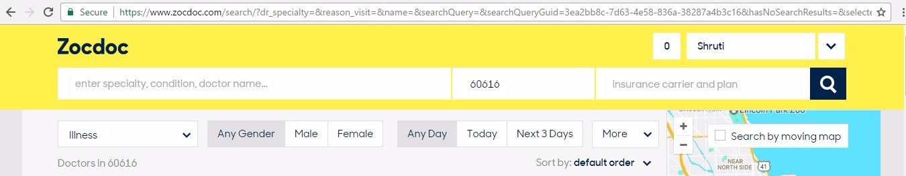

**2. Match between system and the real world** : The words used were clear to book appointment or search for the required doctor such as “doctor name”, “ zip code “ for the area to search in and the “insurance carrier and plan”.

**3. User control and freedom** : Not very easy to go Back to the previous step unless we use the website back link.

**4. Consistency and Standards** : The labels used on the webpage were clear helping the user to click the right tab for the desired action. Standard symbols like the magnifier glass image for search option, the “>” symbol for going forward and a google moving map showing the location of the doctors are all according to what they really mean in the real world.

**5. Error prevention** : There was proper error checking in place and if the user made any mistake in filling out any details there were understandable error messages.

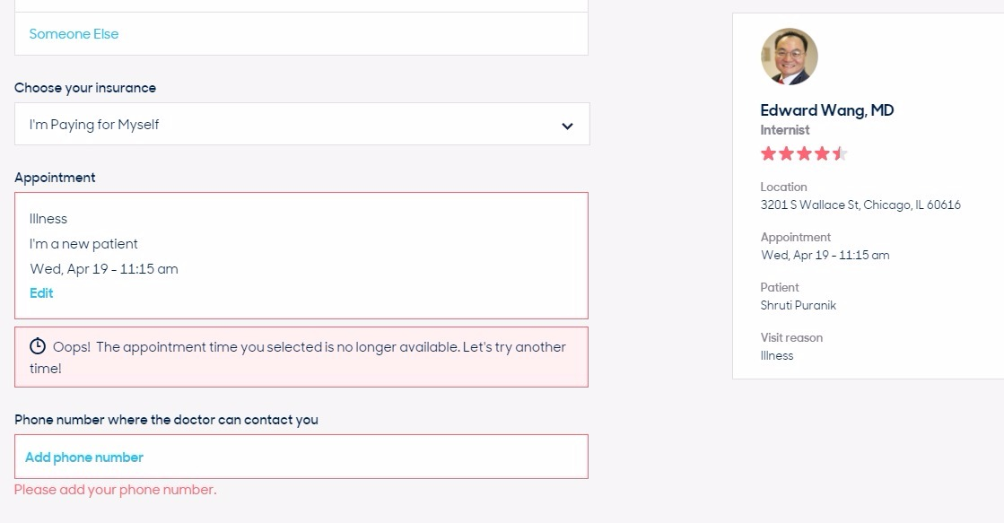

**6. Recognition rather than re-call** : Navigation through the pages is easy as there were minimum options hence less confusing.

**7. Flexibility and efficiency of use** : Not very easy to go Back to the previous step unless we use the website back link. The drop down menu for selecting the illness is very effiecient as the user need not write the down the reason in a text field.

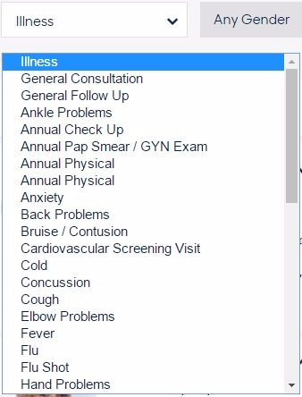

**8. Aesthetic and minimalist design:** The webpage design was good overall. The text and the images were displayed with a proper balance. The color usage was also minimal with only yellow and white. The text was in black. Logo was maintained well at one place on the top left not thus not obstructing the view.

**9. Help Users recognize, diagnose and recover from errors:** The website helps the user during login when he/she enters the incorrect password or username throwing errors in clear language.

**10. Help and Documentation:** It would be better of the Help and FAQ tabs were on the top side of the website instead of being placed way below amongst other options.

**Flow Diagram Goal 1 Buy Medical Insurance**

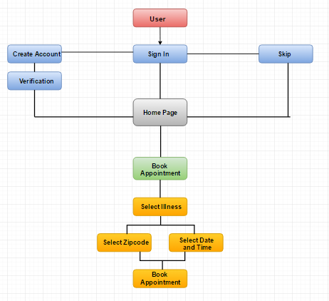

**Paper Prototyping for Med-Ex**

Login/Signup



Menu Page



Goal 2 Book Doctor Appointment

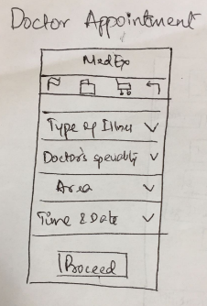

Appointment and Doctor Details

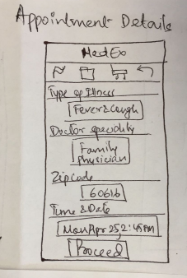

Appointment confirmation

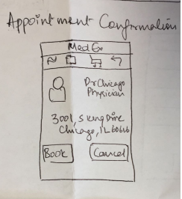

**Low Fidelity Prototype Goal-2 Book Doctor Appointment Iteration 1**



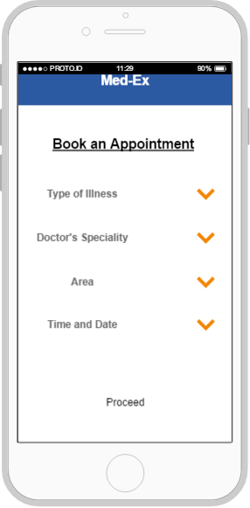   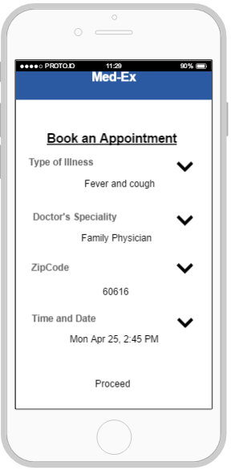

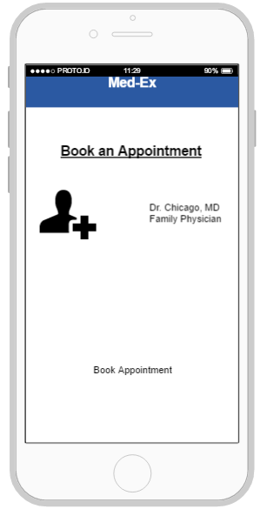

**HEURISTIC EVALUATION ON LOW FIDELITY DIAGRAM**

1. Visibility of system status: The website clearly lets the user know that it is a platform to book doctor appointment. The labels used are clearly understandable.

2. Match between system and the real world : The words used were very specific to book appointment like “Book Appointment“ and ”Proceed”, But the buttons used were more like a text.

3. User control and freedom: Not very easy to go Back to the previous step.

4. Consistency and Standards: The labels were clear as the user could understand if they mean the same thing. For example, the label “Book appointment” to book appointment.

5. Error prevention: There was no proper error checking in place and if the user made any mistake in filling out any details there were no error messages.

6. Recognition rather than re-call: Navigation through the pages is tedious due to no proper back button. There were no proper images to represent the actions performed.

7. Flexibility and efficiency of use: Not very easy to go back to the previous step making the application less flexible, but the application was efficient in terms of performing the task.

8. Aesthetic and minimalist design: The webpage design was not great. There were no proper images displayed in the menu page. The color usage was also minimal. The buttons used were more like a text.

9. Help Users recognize, diagnose and recover from errors: The design was clear and chances of error are minimal.

10. Help and Documentation: There is a help option in the menu page to support the user through his navigation on the web site. There are no FAQ’s which could help the user with some common questions. There is no proper help provided in case the user does not know what to answer for a particular question.

**Low Fidelity Prototype Goal-2 Book Doctor Appointment Iteration 2**

 

 

 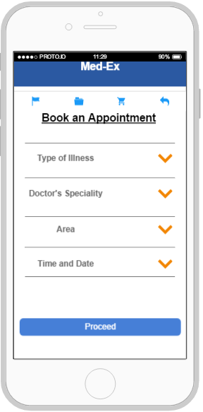

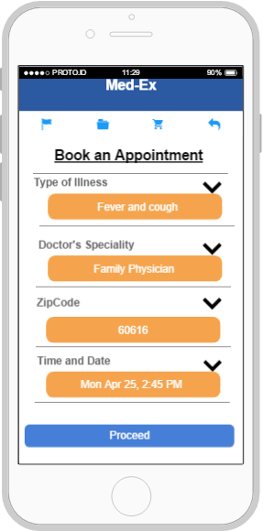 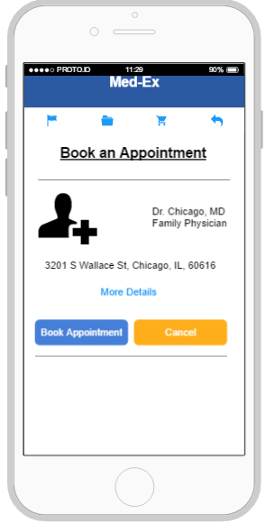

**HEURISTIC EVALUATION ON LOW FIDELITY DIAGRAM**

1. Visibility of system status: The website clearly lets the user know that it is a platform to book doctor appointment. The labels used are clearly understandable.

2. Match between system and the real world : The words used were very specific to book doctor appointment like “ Book Appointment“ and ”Proceed” to continue.

3. User control and freedom: Easy to log out and go back to previous step . User can traverse back easily and could see the doctor details.

4. Consistency and Standards: The labels were clear as the user could understand if they mean the same thing. For example, the label “Book appointment” to book appointment, “Type of Illness” to select illness.

5. Error prevention: There was proper error checking in place and if the user made any mistake in filling out any details there were understandable error messages.

6. Recognition rather than re-call: Navigation through the pages is easy due to back button. There were proper images to represent the actions performed.

7. Flexibility and efficiency of use: User could navigate through the pages easily; User could book an appointment based on the time slot and even based on the zip code hence making the application flexible and efficient.

8. Aesthetic and minimalist design: The webpage design was good overall. The text and the images were displayed with a proper balance. The color usage was also minimal with only blue and white. The text was in black and some important error information was colored in red for example the signup page when user tries to click submit button without entering any details.

9. Help Users recognize, diagnose and recover from errors: The design was clear and chances of error are minimal.

10. Help and Documentation: There is a help option in the menu page to support the user through his navigation on the web site. There are no FAQ’s which could help the user with some common questions. There is no proper help provided in case the user does not know what to answer for a particular question.

**Contextual enquiry for Final Prototype**

**User 1:** Student at IIT, age- 23, User has used multiple mobile applications for expense tracking, however has not used any specific for medical expense tracking. The user has little or no experience with buying an insurance plans. Has been using the one provided by the university.

**Steps:**

1. The user being a first time user of the application clicks on Sign Up.



1. She is asked to fill in details like her name, email id and password. She clicks submit and completes the registration process.



1. The user next is directed to the login screen and enters her username and password and logs in.
2. The user currently is looking for a doctor appointment hence form the menu on the screen she clicks the respective button”Book doctor appointment”.
3. The user is directed to the next screen where she is asked to select details from drop down such as “select type of illness”,”doctor's speciality” and “time and date”.

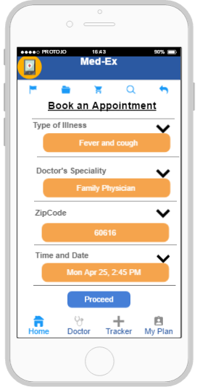

1. She clicks proceed and is directed to a page which displays the details of the doctor such as Doctors name, speciality and the address.
2. The user clicks on the Book appointment button and finalizes the particular doctor.

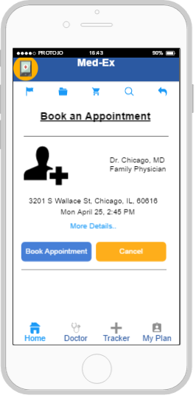

1. The user next navigates to the menu screen and clicks on Buy Insurance button.
2. The user sees a list of insurance plans and decides on United Healthcare plan because her criteria is lowest premium. She clicks on Apply button.
3. The user can now see the details of the insurance plan, she likes the information displayed on the screen and clicks on Buy button.
4. The user now sees order submission details and is given options from various credit cards to pay for the plan. She clicks Buy to finish the purchase.
5. After visiting her doctor, she again logs in to the medex application and clicks on “Expense tracker option” on the menu screen.
6. The user gets a screen displaying details which have to be populated such as “ hospital name”, “medical procedural cost”, “insurance coverage” etc… She notices a “++ symbol on the top corner and clicks the same to add the current expense to the tracker.
7. The user is directed to a screen which shows her the expense details and the final amount she owes after all the deductions. The user is relieved that she does not have to do all the calculations.
8. The user logs out of the application.

**Heuristic Evaluation for Final Prototype**

**1. Visibility of system status:** The application has a smooth transition from one page to another. Each page has clear labels showing the app’s current status that helps the user understand the the app well and is convenient.

**2. Match between system and the real world:** The app uses icons that relate to the function specified, for instance buy insurance option lists the different plans available to choose from and after you buy it also provides with the order confirmation. The shopping cart icon also is a real world description of a purchase made.



**3. User control and freedom**: User can navigate between the options to the home page with ease. At any given point the user has the freedom to choose from the tab bar to navigate directly to the tracker or the book doctor appointment option.

**4. Consistency and Standards**: The labels were real-time and consistent throughout the app, sizing of the images and fonts used, were also well defined. Standard basic colors such as white, blue, orange, grey and black are used.

**5. Error prevention**: There was proper error checking in place and if the user made any mistake in filling out any details there were understandable error messages with preventive action measures.



**6. Recognition rather than re-call:** Payment options are clearly listed for the user to identify the different payment methods. The words used to describe are simple and straightforward. For instance the option to purchase an insurance plan use the word “Buy” - which is a clear representation of the action to be performed.

**7. Flexibility and efficiency of use**: The application is designed in way to have easy access to the primary functions of the app on every page as the tab bar, giving the user flexibility and is efficient by saving time of the user.



**8. Aesthetic and minimalist design**: The application design was good overall. Easily relatable symbols are used through the app for instance dental insurance plans are represented by a tooth symbol, find a doctor is represented by a stethoscope symbol. Minimal colors and options provided throughout the application.

**9. Help Users recognize, diagnose and recover from errors:** The design is simplistic and errors are shown in bold and red which indicates an incorrect input from the user. The error message that pops up also indicates the corrective action to prevent the error.

**10. Help and Documentation:** There is a help option in the home page to support the user while trying to use any of the functions on the app. Each of these options have details of either stepwise tutorials, or knowledge base articles that can be referred to.



**GOAL - Expense Tracker**

**Introduction**

Expensify is a financial engagement platform that allows user to manage expense transactions, upload receipts and creates an expense report. It helps users track & maintain their expenses by providing paperless billing and payment process through paypal.

**Goals to be accomplished by the Team**

* Buy Medical Insurance
* Book Doctors Appointment
* Track Medical Expenses

INDIVIDUAL GOAL - Expense Tracker

**CONTEXTUAL ENQUIRY ON EXISTING WEB PORTAL TO MAINTAIN EXPENSES**

**Task -** Enter & track an expense

Platform - Mobile Application & Web based

**USER 1** - Sales representative- Age 35

The user is a Sales representative at Enablon and has been using the expense tracker - Expensify for tracking her work related expenses, and is familiar with the features provided on the application.

**STEPS -**

1. The user searches for a particular website on Google. (https://www.expensify.com)

2. The user enters Login credentials to log in to the website.

3. The user is shown the homepage with Inbox, Receipts, Expenses and reports

4. The user then selects “New Expense” from the expenses tab, a pop up appears to enter the description of the expense; the user enters medical expense of $4000

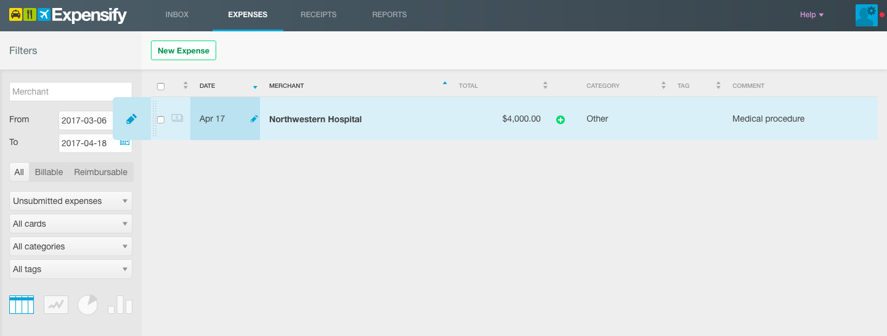

5. After entering the expense the user clicks on “All”; and then selects unreported expenses form the list.

6. The user then sorts the expense based on category by selecting categories “Other”

7. The user enters another expense called the Insurance Deductible for $250 & Medicines

8. User repeats steps 5 & 6

9. The user then clicks on the graph options to show a pictorial representation of the expenses entered

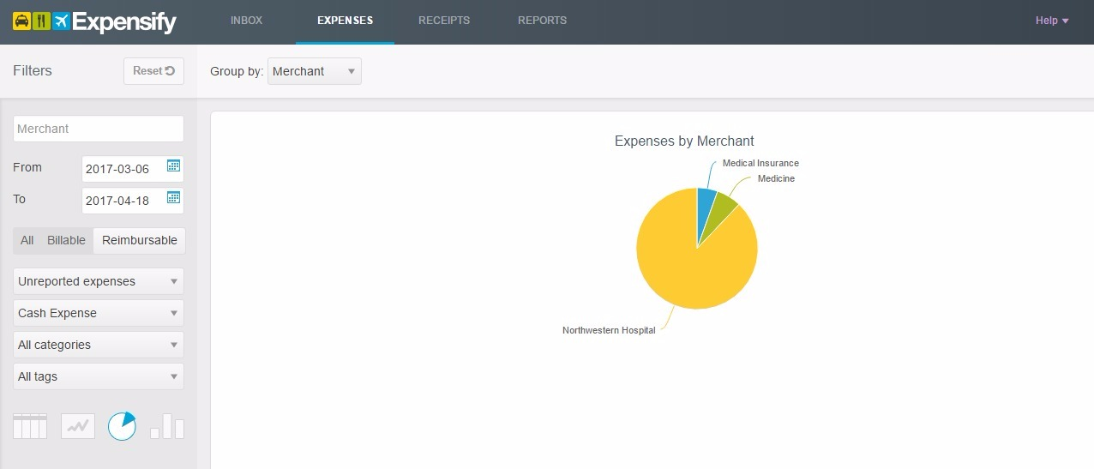

10. The user adds a picture of the receipt for future reference to the expense maid.

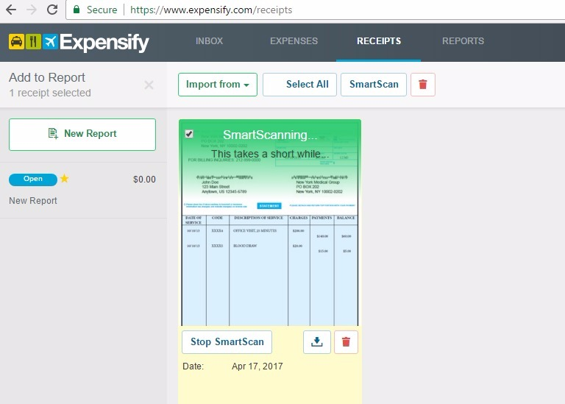

**USER 1 - EXPERIENCE**

The overall experience for the user was good, and she maintained medical expenses on this tool. However, the main purpose of the application is to maintain expenses of travel & food. She could graphically represent her expenses for easier identification & maintenance

**USER 2** - Graduate Admissions Specialist, IIT, Age - 50

The user is a Graduate Admission Specialist at IIT, and has never used any expense tracking applications. Has always maintained her expenses on a balance ledger. She is familiar with using application on her smartphone.

**STEPS -**

1. The user searches for a an expense tracker as suggested by a friend on Google. (https://www.expensify.com)

2. The user then creates an account on expensify

3. The user is shown the homepage with Inbox, Receipts, Expenses and reports

4. The user then clicks on each option to obtain information on usage of the application

5. The user then selects “New Expense” from the expenses tab, a pop up appears to enter the description of the expense

6. User was confused with the options “Reimbursable” & “Billable”, however checked only Billable while entering the medical insurance amount of $2000.

7. User could not find the category for medical expenses on the drop-down list and hence choose the category as other (picture shown below)

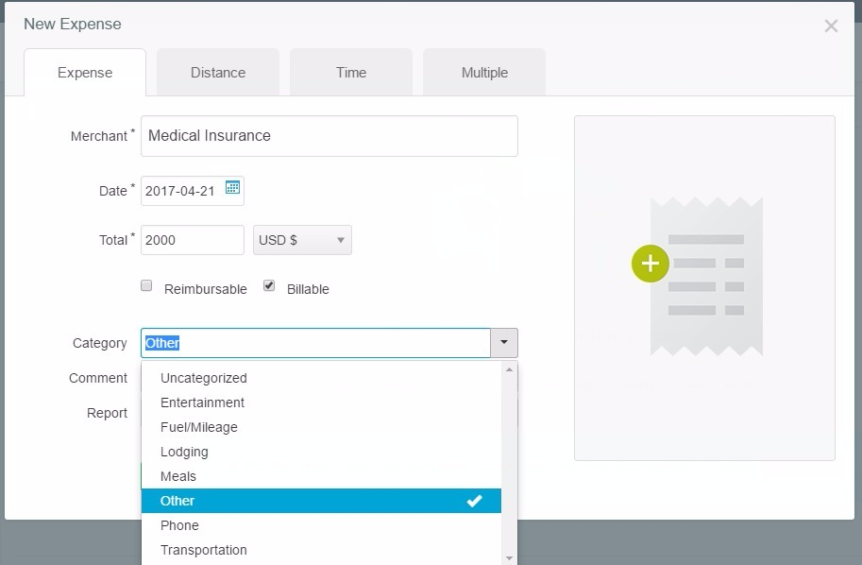

8. After saving the expense the user checks to verify the correctness of the entry, she is however confused with the options listed such as shown below:

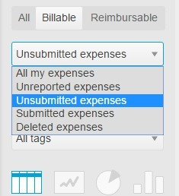

9. She then tries to import the receipt for reference, however she was unable to do so and kept cancelling out of the application

10. The user then looks for assistance/ help on the application and find the help option to direct her on the file formats accepted on the tool

11. User is then able to add receipt on the application and can view the pictorial representation of the medical expense entered.

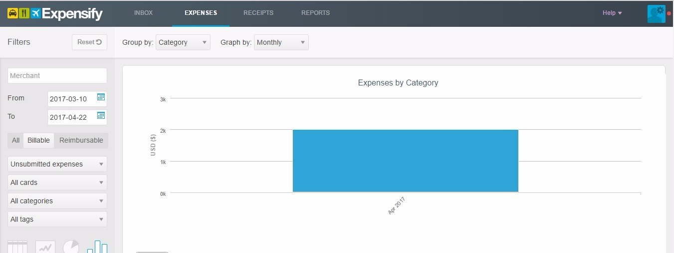

**USER 2 - EXPERIENCE**

The user was very confused and unhappy with the application, she found the directions misleading. Help option did not serve its purpose. However, the graphical representations was easily understandable.

**HEURISTIC EVALUATION ON THE EXISTING WEBSITE**

**TASK - Enter and track expense**

**Platform - Web Site**

**1. Visibility of system status:** The website has the option of adding “New expense” shown explicitly on the expense page.

**2. Match between system and the real world:** The words used to describe categories for billing & the drop down were ambiguous of its usage



**3. User control and freedom**: Option to re-edit the expense after entering is provided to the user and is easily accessible.

**4. Consistency and Standards**: There is ambiguity in words used to describe the expenses entered. There is no search option provided to the user to look for expenses entered. The landing pages for each option were consistent throughout and maintained well.

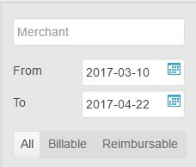

**5. Error prevention:** The error while mandatory columns were not entered shown clearly where the box is highlighted in Red, however the error message was not provided to the user.

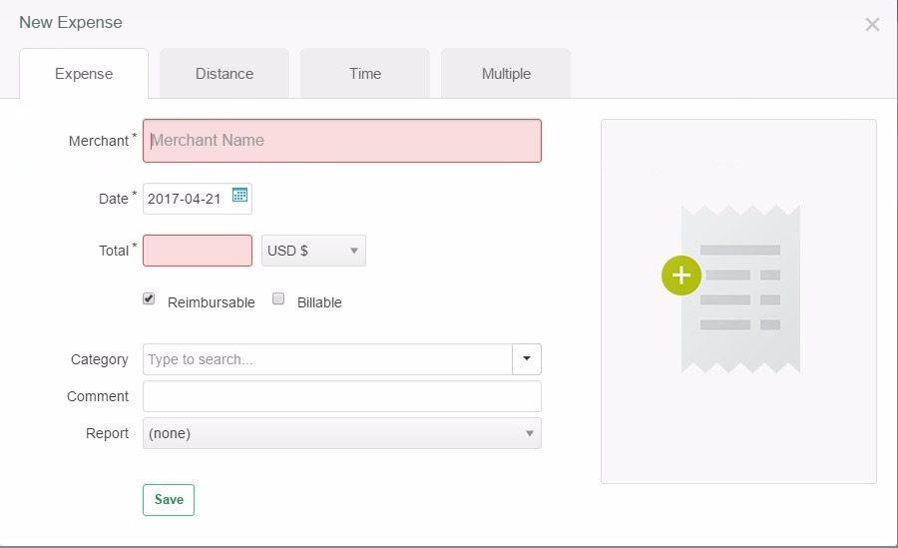

**6. Recognition rather than re-call**: Navigation through the pages is easy as there were minimum options hence less confusing. There were no images to relate to the expense entered and was only dependent on the text.

**7. Flexibility and efficiency of use**: Easy to enter new expenses, options provided to go back and re-edit the expense and has options to enter multiple expenses at once. One can also split the expense after it has been entered. This provides flexibility to the user and is efficient.

**8. Aesthetic and minimalist design**: The landing pages for each option were consistent throughout and maintained well. Colors and font were uniform through the multiple pages on the website. Pastel colors such as blue, white, black & grey were used which is easily viewable to all.

**9. Help Users recognize, diagnose and recover from errors**: The website does not provide easy assistance on errors the user experiences while entering the expense. While scanning the receipts formats accepted are not defined clearly. After the receipt is uploaded the progress of the scan is shown.



**10. Help and Documentation:** Help option first shows a list which is minimal after you click on a specific option the entire documentation on how to enter, maintain and track expenses are defined clearly.

**Flow Diagram Goal 1 Buy Medical Insurance**



**Paper Prototyping for Med-Ex**

Login/Signup



Menu Page



Goal 3 Medical Expense Tracker

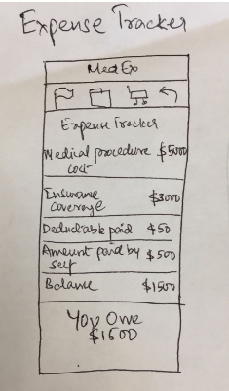

**Low Fidelity Prototype Goal-3 Medical expense Tracker Iteration 1**

 

 

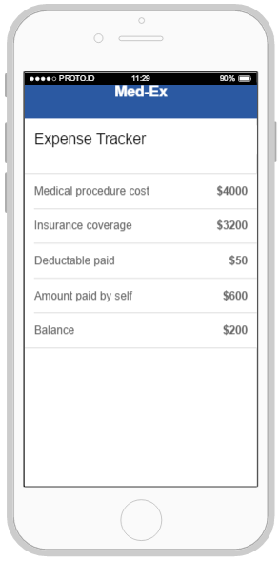

**HEURISTIC EVALUATION ON LOW FIDELITY DIAGRAM**

1. Visibility of system status: The website clearly lets the user know that it is a platform for Medical expense tracker. The labels used are clearly understandable.

2. Match between system and the real world : The words used were very specific to Medical expense tracker. The amount was presented with a $ symbol.

3. User control and freedom: Not very easy to go Back to the previous step.

4. Consistency and Standards: The labels were clear as the user could understand if they mean the same thing. The application followed the standards and is consistent.

5. Error prevention: There was no proper error checking in place and if the user made any mistake in filling out any details there were no error messages.

6. Recognition rather than re-call: Navigation through the pages is tedious due to no proper back button. There were no proper images to represent the actions performed.

7. Flexibility and efficiency of use: Not very easy to go back to the previous step making the application less flexible, but the application was efficient in terms of performing the task.

8. Aesthetic and minimalist design: The webpage design was not great. There were no proper images displayed in the menu page. The color usage was also minimal. The buttons used were more like a text.

9. Help Users recognize, diagnose and recover from errors: The design was clear and chances of error are minimal.

10. Help and Documentation: There is a help option in the menu page to support the user through his navigation on the web site. There are no FAQ’s which could help the user with some common questions. There is no proper help provided in case the user does not know what to answer for a particular question.

**Low Fidelity Prototype Goal-2 Book Doctor Appointment Iteration 2**

 

 

 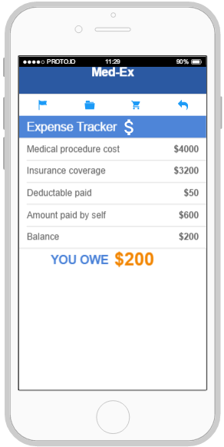

**HEURISTIC EVALUATION ON LOW FIDELITY DIAGRAM**

1. Visibility of system status: The website clearly lets the user know that it is a platform for Medical Expense Tracking. The labels used are clearly understandable.

2. Match between system and the real world: The words used were very specific to medical expense tracking. Symbols like “$” to represent the expenses.

3. User control and freedom: Easy to log out and go back to previous step . User can traverse back easily and could see the expenses.

4. Consistency and Standards: The labels were clear as the user could understand if they mean the same thing. Expenses were represented using $ symbol.

5. Error prevention: There was proper error checking in place and if the user made any mistake in filling out any details there were understandable error messages.

6. Recognition rather than re-call: Navigation through the pages is easy due to back button. There were proper images to represent the actions performed.

7. Flexibility and efficiency of use: User could navigate through the pages easily hence making the application flexible and efficient.

8. Aesthetic and minimalist design: The webpage design was good overall. The text and the images were displayed with a proper balance. The color usage was also minimal with only blue and white. The text was in black and some important error information was colored in red for example the signup page when user tries to click submit button without entering any details.

9. Help Users recognize, diagnose and recover from errors: The design was clear and chances of error are minimal.

10. Help and Documentation: There is a help option in the menu page to support the user through his navigation on the web site. There are no FAQ’s which could help the user with some common questions. There is no proper help provided in case the user does not know what to answer for a particular question.

**Contextual enquiry for Final Prototype**

**User 1:** Student at IIT, age- 23, User has used multiple mobile applications for expense tracking, however has not used any specific for medical expense tracking. The user has little or no experience with buying an insurance plans. Has been using the one provided by the university.

**Steps:**

1. The user being a first time user of the application clicks on Sign Up.



1. She is asked to fill in details like her name, email id and password. She clicks submit and completes the registration process.



1. The user next is directed to the login screen and enters her username and password and logs in.

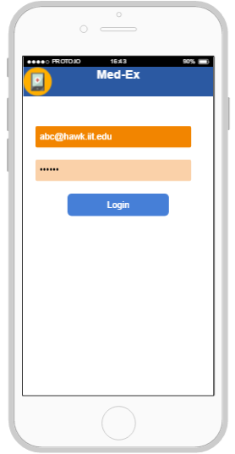

1. The user currently is looking for a doctor appointment hence form the menu on the screen she clicks the respective button”Book doctor appointment”.
2. The user is directed to the next screen where she is asked to select details from drop down such as “select type of illness”,”doctor's speciality” and “time and date”.
3. She clicks proceed and is directed to a page which displays the details of the doctor such as Doctors name, speciality and the address.
4. The user clicks on the Book appointment button and finalizes the particular doctor.
5. The user next navigates to the menu screen and clicks on Buy Insurance button.
6. The user sees a list of insurance plans and decides on United Healthcare plan because her criteria is lowest premium. She clicks on Apply button.
7. The user can now see the details of the insurance plan, she likes the information displayed on the screen and clicks on Buy button.
8. The user now sees order submission details and is given options from various credit cards to pay for the plan. She clicks Buy to finish the purchase.
9. After visiting her doctor, she again logs in to the medex application and clicks on “Expense tracker option” on the menu screen.

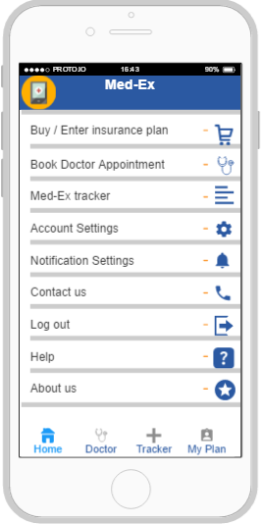

1. The user gets a screen displaying details which have to be populated such as “ hospital name”, “medical procedural cost”, “insurance coverage” etc… She notices a “++ symbol on the top corner and clicks the same to add the current expense to the tracker.

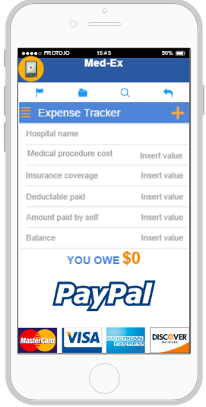

1. The user is directed to a screen which shows her the expense details and the final amount she owes after all the deductions. The user is relieved that she does not have to do all the calculations.

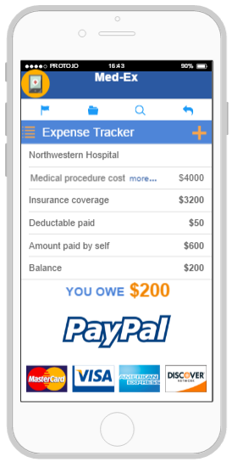

1. The user logs out of the application.

**Heuristic Evaluation for Final Prototype**

**1. Visibility of system status:** The application has a smooth transition from one page to another. Each page has clear labels showing the app’s current status that helps the user understand the the app well and is convenient.

**2. Match between system and the real world:** The app uses icons that relate to the function specified, for instance buy insurance option lists the different plans available to choose from and after you buy it also provides with the order confirmation. The shopping cart icon also is a real world description of a purchase made.



**3. User control and freedom**: User can navigate between the options to the home page with ease. At any given point the user has the freedom to choose from the tab bar to navigate directly to the tracker or the book doctor appointment option.

**4. Consistency and Standards**: The labels were real-time and consistent throughout the app, sizing of the images and fonts used, were also well defined. Standard basic colors such as white, blue, orange, grey and black are used.

**5. Error prevention**: There was proper error checking in place and if the user made any mistake in filling out any details there were understandable error messages with preventive action measures.



**6. Recognition rather than re-call:** Payment options are clearly listed for the user to identify the different payment methods. The words used to describe are simple and straightforward. For instance the option to purchase an insurance plan use the word “Buy” - which is a clear representation of the action to be performed.

**7. Flexibility and efficiency of use**: The application is designed in way to have easy access to the primary functions of the app on every page as the tab bar, giving the user flexibility and is efficient by saving time of the user.



**8. Aesthetic and minimalist design**: The application design was good overall. Easily relatable symbols are used through the app for instance dental insurance plans are represented by a tooth symbol, find a doctor is represented by a stethoscope symbol. Minimal colors and options provided throughout the application.

**9. Help Users recognize, diagnose and recover from errors:** The design is simplistic and errors are shown in bold and red which indicates an incorrect input from the user. The error message that pops up also indicates the corrective action to prevent the error.

**10. Help and Documentation:** There is a help option in the home page to support the user while trying to use any of the functions on the app. Each of these options have details of either stepwise tutorials, or knowledge base articles that can be referred to.

